**PRACTICAL NO: 7A**

**Aim:** Create an android app to connect to the internet.

Code:

Activity_main.xml:

<?xml version="1.0" encoding="utf-8"?>

<RelativeLayout xmlns:android="http://schemas.android.com/apk/res/android"

xmlns:app="http://schemas.android.com/apk/res-auto"

xmlns:tools="http://schemas.android.com/tools"

android:layout_width="match_parent"

android:layout_height="match_parent"

tools:context=".MainActivity">

<Button

android:layout_width="wrap_content"

android:layout_height="wrap_content"

android:text="CHECK INTERNET"

android:layout_centerInParent="true"

android:id="@+id/check"/>

</RelativeLayout>

MainActivity.java:

package com.example.practical07;

import androidx.appcompat.app.AppCompatActivity;

import android.content.Context;

import android.net.ConnectivityManager;

import android.net.NetworkInfo;

import android.os.Bundle;

import android.view.View;

import android.widget.Button;

import android.widget.Toast;

public class MainActivity extends AppCompatActivity implements View.OnClickListener{

Button btn;

@Override

protected void onCreate(Bundle savedInstanceState) {

super.onCreate(savedInstanceState);

setContentView(R.layout.activity_main);

btn=findViewById(R.id.check);

btn.setOnClickListener(this);

}

@Override

public void onClick(View v) {

if(isConnected())

Toast.makeText(getApplicationContext(),

"INTERNET AVAILABLE", Toast.LENGTH_SHORT).show();

else

Toast.makeText(getApplicationContext(),"INTERNET NOT AVAILABLE",Toast.LENGTH_SHORT).show();

}

boolean isConnected(){

ConnectivityManager connectivityManager = (ConnectivityManager)

getSystemService(Context.CONNECTIVITY_SERVICE);

NetworkInfo networkInfo = connectivityManager.getActiveNetworkInfo();

if(networkInfo!=null){

if(networkInfo.isConnected())

return true;

else

return false;

}else

return false;

}

}

AndroidManifest.xml:

<?xml version="1.0" encoding="utf-8"?>

<manifest xmlns:android="http://schemas.android.com/apk/res/android"

xmlns:tools="http://schemas.android.com/tools">

<uses-permission android:name="android.permission.ACCESS_NETWORK_STATE" />

<application

android:allowBackup="true"

android:dataExtractionRules="@xml/data_extraction_rules"

android:fullBackupContent="@xml/backup_rules"

android:icon="@mipmap/ic_launcher"

android:label="@string/app_name"

android:supportsRtl="true"

android:theme="@style/Theme.Practical07"

tools:targetApi="31">

<activity

android:name=".MainActivity"

android:exported="true">

<intent-filter>

<action android:name="android.intent.action.MAIN" />

<category android:name="android.intent.category.LAUNCHER" />

</intent-filter>

</activity>

</application>

</manifest>

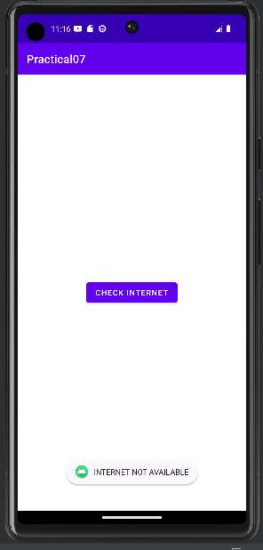Output:

